Smart city solutions
Vortex is the UK’s leading provider of smart city solutions.
We provide environmental sensors, networks and data solutions to support decarbonisation efforts globally. We drive real environmental change by leveraging the power of real-time data with cleantech technologies.
As experts in the latest IoT, AI, 5G, and LiDAR technologies, Vortex enables smart cities and smart infrastructures to become more efficient, safer and greener.
Monitor what matters; Act where it counts. – Vortex’s sensor technology maximises visibility and delivers the actionable data that our clients need to start making smarter decisions.

Our solutions :-
Air quality monitoring

Providers of the largest air quality sensor deployment in Europe, Vortex’s Air Pollution sensors provide on demand insights you can act on. Reduce air pollution and achieve environmental compliance with street-level data and constant visibility. Measure. Monitor. Act.
The VTX Air quality monitor provides accurate insights to support data-driven decisions and drive environmental change. Our fit and forget technology provides accurate, street-level insights on air quality. That’s data you can use to make impactful environmental interventions

Learn more
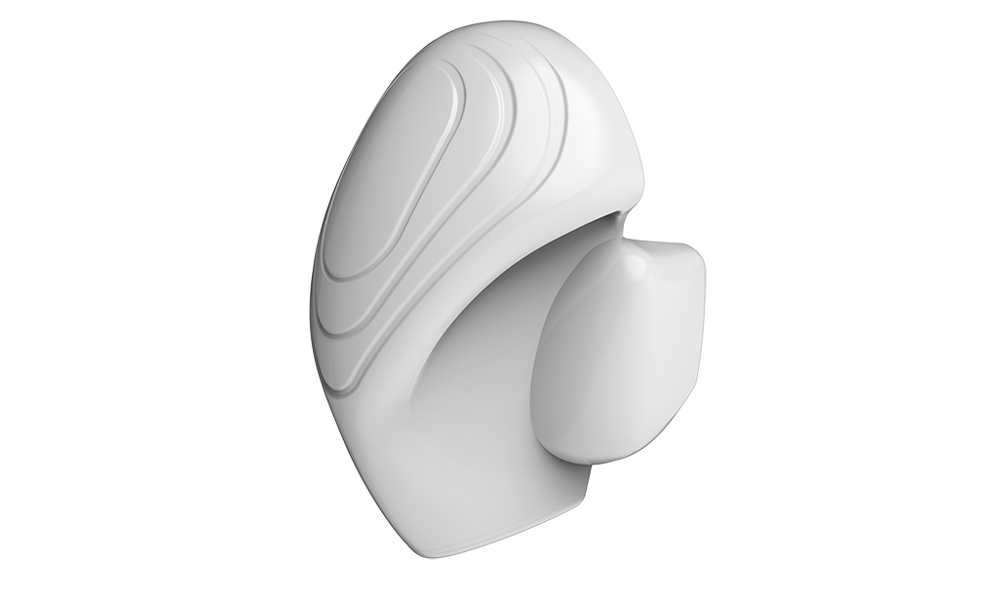
Industrial pollution monitoring
As an industrial business, the legislative requirements surrounding air pollution monitoring are only set to get more demanding. Monitor, analyse and act on hyper-local emission data around your site to stay compliant. Use on-demand data for effective compliance and easy reporting.
Learn more
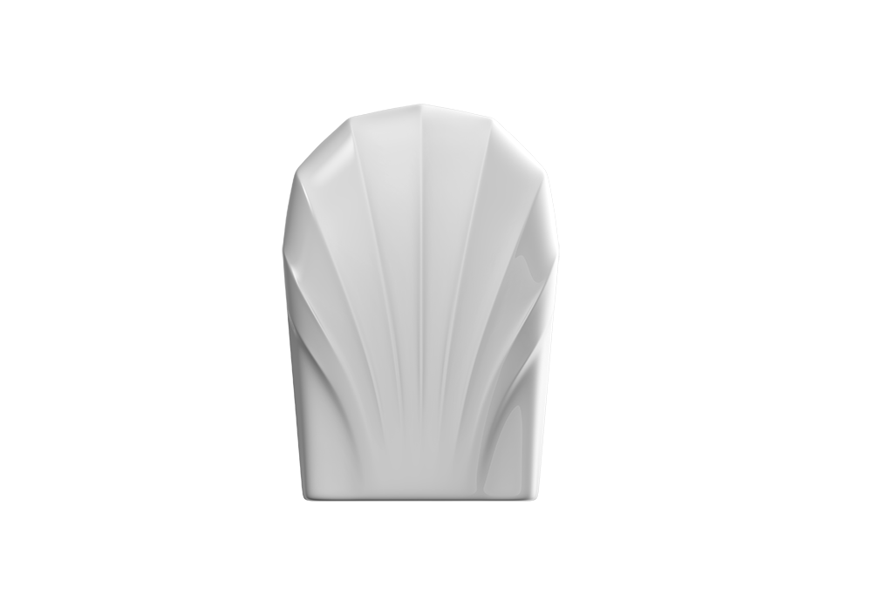
Pollution reduction schemes
Combine hyperlocal air quality monitoring networks with the latest in traffic management technology for unprecedented insights. Integrate pollution data with real-time traffic data to capture the impact of congestion on air quality and use the intelligence to make targeted interventions and reduce pollution.
Learn more
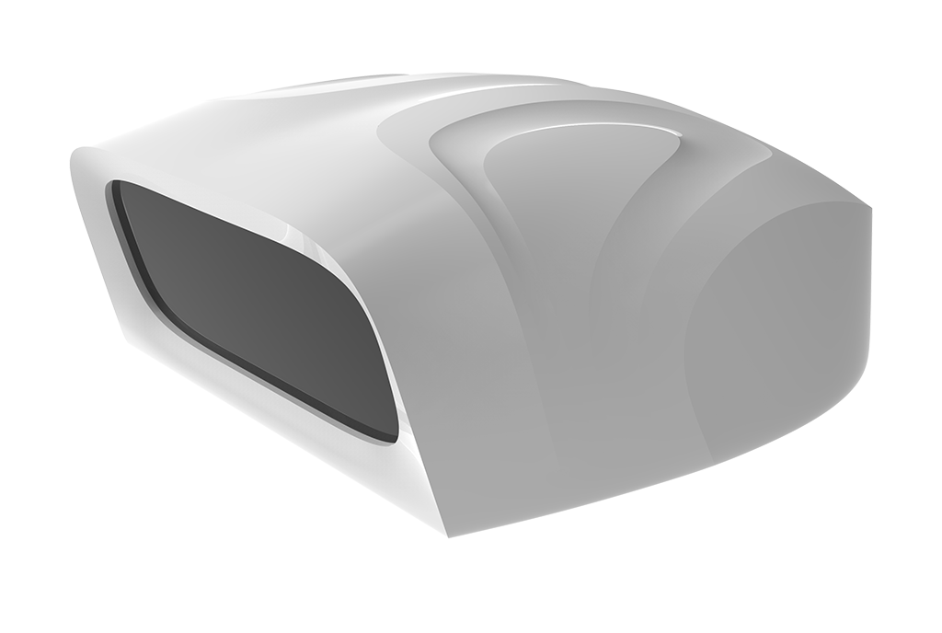
Continuous urban scanning
VTX City is the continuous urban scanner that allows you to monitor and optimise your city assets in real-time. Build safer, smarter and more sustainable cities with dynamic, city wide scanning, executed autonomously over the 5G network.
Learn more
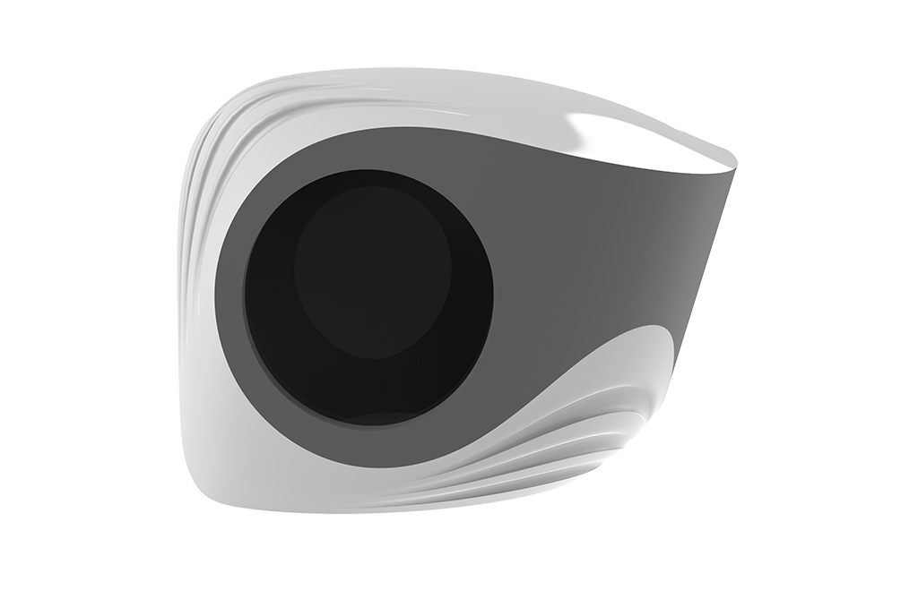
Remote infrastructure management
VTX Infra monitors highway and rail assets 24/7, providing high-level reporting of data to identify the location, condition and nature of any risks. Use our advanced obstruction and intrusion recognition to recognise, report and resolve infrastructure issues.
Learn more
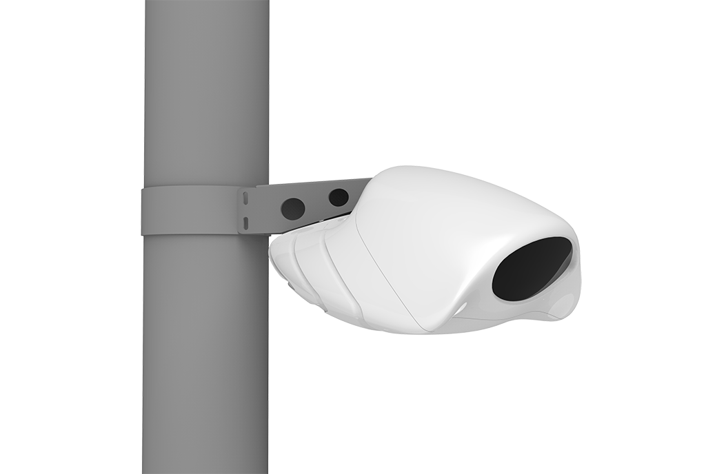
Smart parking systems
Save drivers time and improve customer experience with parking space monitoring. Access actionable data on parking space availability in real-time, with air quality monitoring add-ons available.
Learn more

